**Phase 4: Performance of the Project**

**Title: Natural Disaster Prediction Management**

**Objective:**

The objective of Phase 4 is to enhance the overall performance of the Natural Disaster Prediction and Management system by refining prediction models for greater accuracy, optimizing system scalability, and ensuring seamless handling of increased data volumes. Additionally, this phase focuses on strengthening the alert system, integrating real-time data sources, and implementing robust security measures to ensure data integrity and reliability.

**1. Predictive Model Optimization**

**Overview:**

The predictive model will be refined using comprehensive datasets, encompassing historical data and real-time sensor inputs, to improve accuracy in forecasting natural disasters such as floods, earthquakes, and cyclones. The objective is to reduce false positives and negatives while ensuring timely and accurate predictions.

**Key Enhancements:**

● Data Augmentation: Expanded datasets will be incorporated, including historical weather patterns, seismic activity, and sensor data for enhanced predictive accuracy.

● Model Optimization: Advanced techniques such as hyper parameter tuning, feature selection, and model pruning will be employed to improve computational efficiency and prediction accuracy.

**Outcome:**

The refined predictive model will demonstrate heightened accuracy, minimizing false alerts and facilitating more reliable disaster forecasting.

**2. Enhanced Alert System**

**Overview:**

The alert system will be optimized to deliver rapid, accurate, and multi-channel notifications, including SMS, email, and app-based alerts. The objective is to ensure timely communication with affected populations based on predictive model outputs.

**Key Enhancements:**

● Reduced Response Time: Optimization of the alert generation framework to minimize latency and expedite notification delivery.

● Multichannel Integration: Seamless integration of various communication channels to broaden the reach of disaster alerts, ensuring comprehensive coverage.

**Outcome:**

The alert system will operate more efficiently, delivering timely alerts across multiple platforms with minimal response time.

**3. Real-Time Data Integration and Analysis**

**Overview:**

This phase emphasizes the integration of real-time data streams from sensors, weather monitoring systems, and IoT devices to provide accurate, actionable insights. Enhanced data processing capabilities will facilitate faster analysis of incoming data to predict potential disasters.

**Key Enhancements:**

● Data Pipeline Optimization: Implementation of optimized data pipelines to handle high data volumes without latency.

● Advanced API Integration: Enhanced API connections to external data sources to ensure timely data acquisition and analysis.

**Outcome:**

By the end of Phase 4, the system will seamlessly integrate real-time data, enabling more accurate predictions and timely alerts.

**4. Data Security and Privacy Reinforcement**

**Overview:**

Phase 4 will address potential data security vulnerabilities, focusing on data encryption, secure communication protocols, and comprehensive security testing to protect sensitive information.

**Key Enhancements:**

● Encryption Protocols: Deployment of advanced encryption standards to secure data transmission and storage.

● Vulnerability Assessment: Comprehensive security testing to identify potential risks and implement necessary safeguards.

**Outcome:**

The system will adhere to stringent data security standards, ensuring the integrity and confidentiality of user data under high data loads.

**5. Performance Testing and Metrics Analysis**

**Overview:**

Comprehensive performance testing will assess the system's ability to handle simultaneous disaster events and increased data volumes. Key metrics such as response time, data processing speed, and system throughput will be collected and analyzed.

**Implementation:**

● Load Testing: Simulated high-traffic scenarios to evaluate system stability under increased data loads.

● Metrics Analysis: Detailed analysis of response times, data processing rates, and system scalability to identify performance bottlenecks.

**Outcome:**

By the end of Phase 4, the system will be fully optimized to handle real-time data, provide accurate predictions, and deliver timely alerts with minimal latency.

**Key Challenges in Phase 4:**

1. Data Accuracy Issues: Ensuring prediction models provide accurate and reliable disaster forecasts.

2. System Overload: Handling heavy data traffic during multiple disaster alerts without system crashes.

3. User Acceptance: Making the system easy for all users, including those unfamiliar with technology.

4. Communication Delays: Ensuring alerts reach users quickly, even in remote areas.

5. Security Risks: Protecting sensitive data from potential cyber threats or unauthorized access.

**Outcomes of Phase 4:**

1. Accurate Predictions: Enhanced accuracy in predicting natural disasters, reducing false alarms.

2. Timely Alerts: Faster and more reliable delivery of disaster alerts to affected communities.

3. User Feedback Integration: Improved user interface based on feedback for better usability.

4. System Stability: Ensured system stability under heavy data inflows and simulated disaster scenarios.

5. Data Security Strengthened: Identified and resolved potential security vulnerabilities to safeguard data.

### ****Source Code Screenshot &** Output Screenshot**

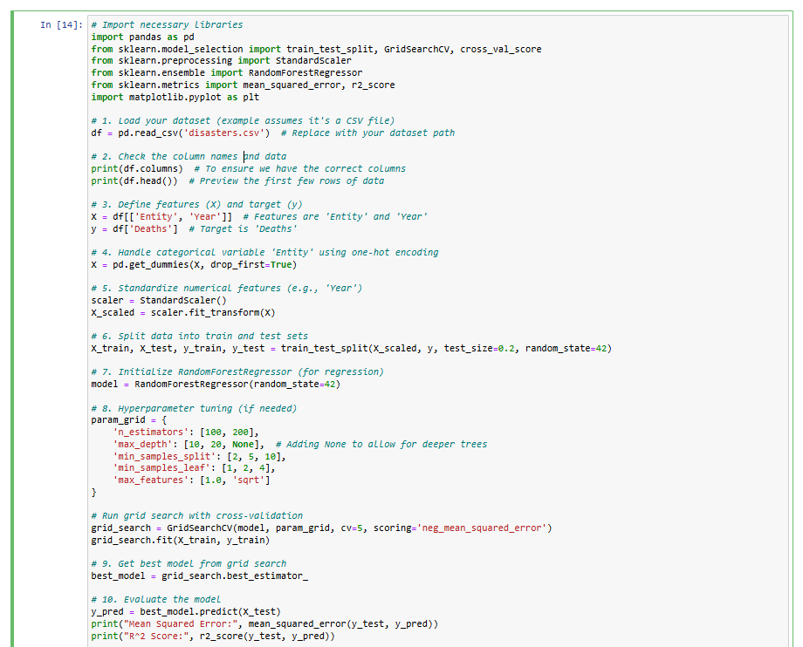

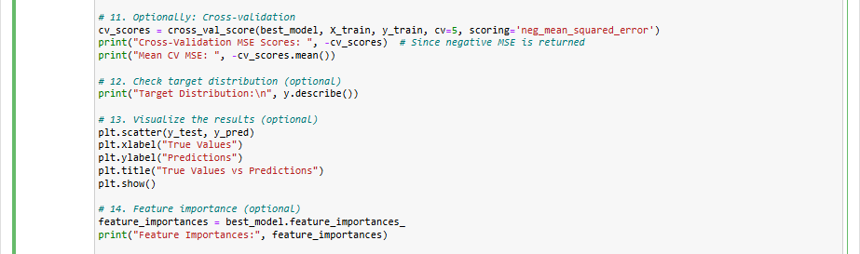

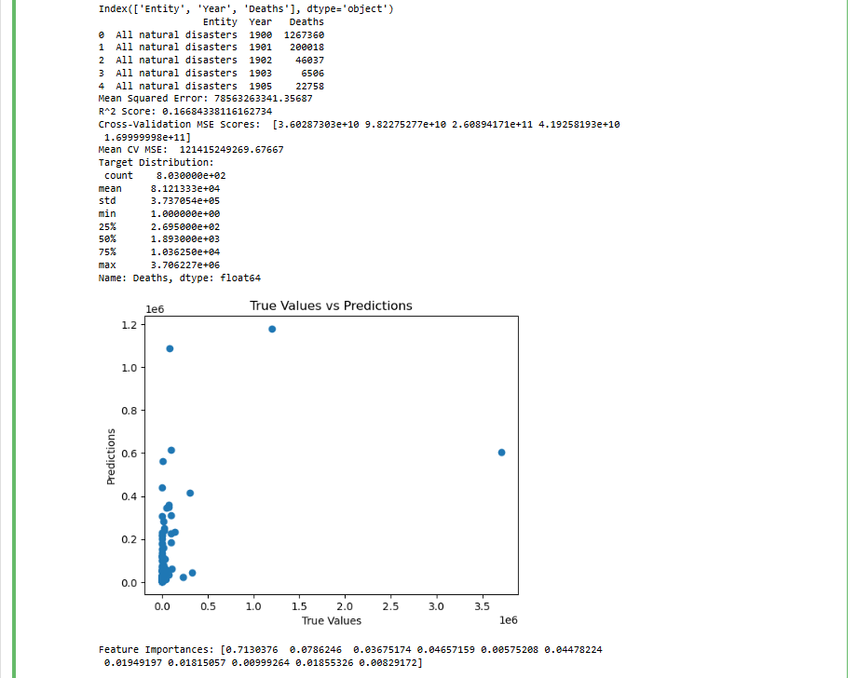

**Source code on GitHub:**

https://github.com/aswini125/natural-disaster-prediction-management